Retake
2A and 6C

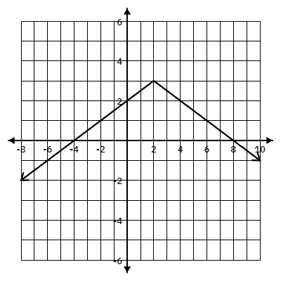
- Using the graph provided answer the following:
  - Domain:________________
  - Range: _________________
  - Min/Max: _______________
  - Vertex: _________________
  - X-int(s): ________________
  - Y-int: __________________
  - Verbal Description: ___________________

- $f(x)= |x+3|-5$
  - Domain:________________
  - Range: _________________
  - Min/Max: _______________
  - Vertex: _________________
  - X-int(s): ________________
  - Y-int: __________________
  - Verbal Description:_________________________________________________
- $f(x)= \frac{1}{2}|x-6|-7$
  - Domain:________________
  - Range: _________________
  - Min/Max: _______________
  - Vertex: _________________
  - X-int(s): ________________
  - Y-int: __________________
  - Verbal Description:_________________________________________________
- $f(x)= -3|x+9|+6$
  - Domain:________________
  - Range: _________________
  - Min/Max: _______________
  - Vertex: _________________
  - X-int(s): ________________
  - Y-int: __________________
  - Verbal Description:_________________________________________________

2A. Given the following key attributes of an absolute value function:
- Domain: All real numbers
- Shifted Horizontal 2 units Right
- Shifted Vertically 3 units up
- Passes through the point of (-4,0)
What is the Equation?_________________________________________________________

